**HANDS-ON 5**

**Objectives**

**Explain how to clean up and push back to remote Git**

How to clean up and push back to remote Git

1. Check the status to see if there are any changes that need to be committed:

git status

1. Stage your changes (add files you want to commit):

git add .

1. Commit your changes with a meaningful message:

git commit -m "Your commit message"

1. Pull the latest changes from the remote branch to avoid conflicts:

git pull origin main

*(Replace main with your branch name)*

1. Push your committed changes back to the remote repository:

git push origin your-branch-name

**1. Verify if main branch is in a clean state**

**Command:**

git status

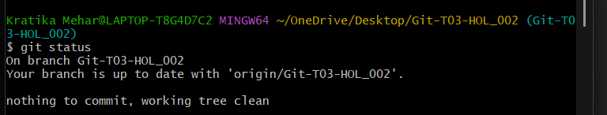

**2. Create a test file with some content**

**Command:**

echo "This is a test change" > testfile.txt

**3. Add the new file to staging**

**Command:**

git add testfile.txt

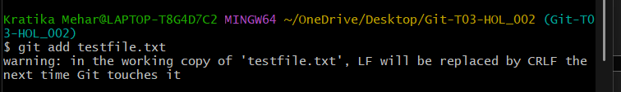

**4. Commit the changes**

**Command:**

git commit -m "Added testfile.txt to verify push functionality"

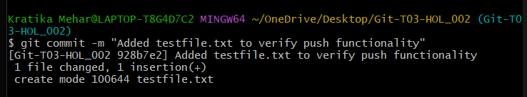

**5. Push the changes to remote**

**Command:**

git push origin Git-T03-HOL_002

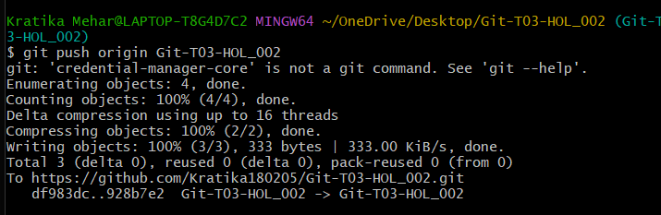

**6. Verify the latest commit pushed**

**Command:**

git log -1

